Minerals, Rocks and Resources Review

Minerals:
A mineral is : naturally occurring, solid, homogenous (uniform throughout), and inorganic (cannot be made from any living or once living thing)

Minerals are identified according to:
1.) Chemical Composition: what it’s made of ex: Quartz (SiO2), Graphite (C)

2.) Physical Properties: color, streak, hardness, crystal habit, cleavage, fracture and luster
*All physical properties are dependent upon: The internal arrangement of atoms!!!

a.) Color: the problem with using color to identify a mineral is
-the same mineral can have different colors (like calcite and quartz)
-different minerals can have the same color (like gold and pyrite, calcite
And quartz)
You must use BETTER tests to identify the physical properties
*The best!b.) Hardness- a minerals resistance to being scratched and/or how ABRASIVE it is.
Ex: Quartz & Garnet=7 so they are often used as abrasives as they scratch other material easily
Hard= will scratch glass, Soft=will not scratch glass
*A mineral can only be scratched by something that is AS hard or harder than it is

c.) Luster- Metallic (looks like metal and reflects all light) vs. Non-metallic
d.) Crystal Habit- This is the shape a mineral has if it is formed in PERFECT conditions
ex: Halite is Cubic (looks like cubes)
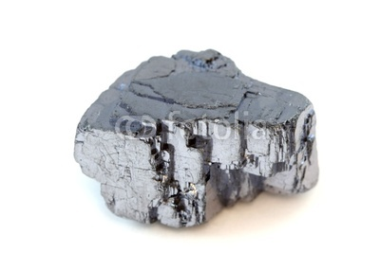
Calcite is rhombic (looks like rhombohedra)
e.) Breakage:
Cleavage: The mineral with break in CLEAN FLAT planes- this is due to the atoms being arranged in an ordered pattern →
Ex: Mica and biotite break in flat sheets naturally
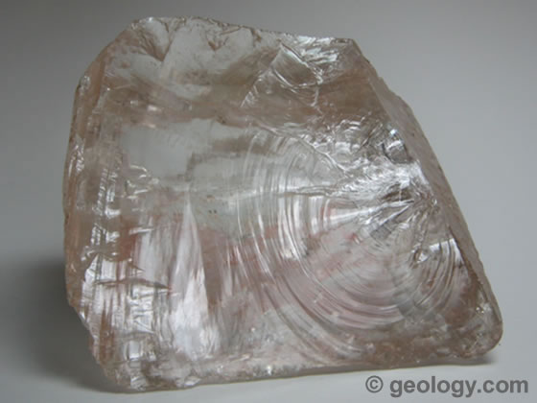
When I threw the block of halite on the floor it broke into clean squares .
VS. Fracture: The mineral will break unevenly looking either rough, jagged, or curved
← Ex: Quartz, pyrite

Question: Why are Diamond and Graphite both made out of elemental carbon (just C), yet have different physical properties?

Because Si and O are the most abundant elements in the crust they are found in many of the 12 common minerals. Likewise, those 12 common minerals make up most of the many sedimentary, igneous, and metamorphic rocks we see everyday. Just a few minerals make up most of the rocks we see.
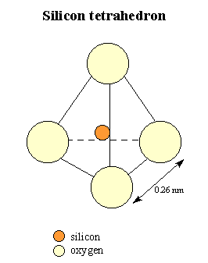
Silicates Mineral Group

Are composed of Si and O
They form a Silica-Oxygen Tetrahedron
Ex: Quartz, K-feldspar
Rocks
*Rocks are FIRST classified according to how they are formed/their origin*

1.) Sedimentary-most are formed from the compaction and cementation of sediments in watery environments after deposition (oceans, streams, rivers, lakes). They are deposited in FLAT LAYERS.
Three Types:
A.) Clastic- Any sedimentary rock composed of fragments (sediments) held together by cement
CEMENTS (rock glue)-formed from minerals precipitating out of saturated water

Includes: Conglomerates, Breccia, Sanstones, Siltstones, Shales
B.) Bioclastic – are sed. rocks made from once living organisms
Ex: Coal –made from dead plant matter
Coquina Fossil Limestone- made from calcite in the form of shells

C.) Crystalline- are rocks made from the precipitation and evaporation of minerals which form a crystalline structure
Ex: regular limestone (calcite), rocksalt (halite), Rock Gypsum

Fossils: Fossils are found in sedimentary rock because organisms are able to make an imprint underwater as they settle and are compressed in the sediment

Grain Size: From smallest to largest: Clay→Silt→Sand→Gravel→Pebbles→Boulders

*If a rock is truly limestone it will react with ACID b/c it is composed of calcite

2.) Igneous Rocks –are formed from the solidification of magma/lava (molten rock that has melted)
Igneous rocks are further divided into the environments from which they formed which effects
The texture/appearance of the rock

A.) Extrusive or “Volcanic” Rocks – form OUTSIDE a volcano or any type of volcanic environment
Where the lava cools much “faster”
Key Characteristics:
1.) a finer grain size (basalt) or are non-crystalline with glassy texture (ex: obsidian)
2.) can be vesicular- gas pockets that explode in lava leaving bubbles in rock (ex:pumice)

B.) Intrusive or “Pluntonic” Rocks- form INSIDE the earth where magma take 100’s of thousands of years to cool (even millions)
Key Characteristics:
1.) A coarser grain size (larger crystals) ex: Granite or even pegmatites (HUGE Xstals)

Chemical Composition of Igneous Rocks: (bottom of page 6 ESRT)
1.) FELSIC- has minerals with a higher % of Al and Si; are light in color. Felsic rocks are less dense than mafic rocks. (Left side of diagram on pg 6 ESRT)

2.) MAFIC- has minerals with a higher % of Fe and Mg; are DARK in color an much more dense than felsic rocks (Right side of diagram on pg 6 ESRT)

3.) Intermediate- rocks fall in the middle of the diagram and are equal & of mafic and felsic minerals:
ex: diorite and andesite (looks like a spotted snow leapord OR is plain grey)

*Know how to use your chart!: For example, an igneous rock which is felsic, formed in an extrusive environment and is fine grained with the same composition as granite is : Rhyolite

3.) Metamorphic Rocks- formed from an increase in Temperature and Pressure=metamorphism

Causes Re-crystalization where: (1) New minerals form
(2) Existing crystals grow larger
Two Types:
a.) Regional Metamorphism: is the most common. It occurs at great depth below the surface
where T and P are very high. This also is typical in convergence
zones/ mountain building where directional P is extremely high.
Characteristics:
Reg. Met. Rocks can show FOLIATION- where the mineral grains align themselves due to high directional pressure. Gneiss is a rock which shows
Foliation in the form of BANDING (looks like zebra stripes!)

Typical increase in foliation due to ↑ metamorphic grade (more T more P)
Example:
Shale (sedimentary)→Slate→Phyllite→Schist -→Gneiss

b.) Contact Metamorphism : Occurs where pre-existing rock comes into contact
with an igneous intrusion (where magma rises up through crust)
Temperature is the major player here not P.
Varied rock types of rock→Hornfels
Limestone-→marble
Sandstone→quartzite
Bituminous coal→anthracite
Resources
1.) Renewable Resource- can be replenished as fast as it is consumed
Ex: solar energy, biofuel (wood), wind, geothermal (heat from the earth)
2.) Non-Renewable Resource- can not be created as fast as it is consumed
Ex: Fossil Fuels- formed in sedimentary rocks
a.) Coal- made from plants (electricity)
b.) Petroleum/gasoline- made from living organisms (powers cars)
c.) Natural Gas/Methane- “ “ “ “ ← What we are trying to extract now

Lab Practical: A great website for you to flip through to review: http://faculty.icc.edu/easc111lab/labs/labb/

Be able to identify the following:
Sed. Rocks: conglomerate, sandstone, shale, breccia, limestone (both types!)

Igneous Rocks: obsidian, basalt, gabbro, granite, rhyolite, diorite, pumice

Metamorphic Rocks: gneiss, schist, slate, marble, quartzite

Minerals: Galena, quartz, calcite, sulfur, hematite, k-feldspar (orthoclase), pyrite, halite

